Press Release

Jennifer Morrison – The Depth of Things
11 July – 22 August
Barnard Gallery, Cape Town

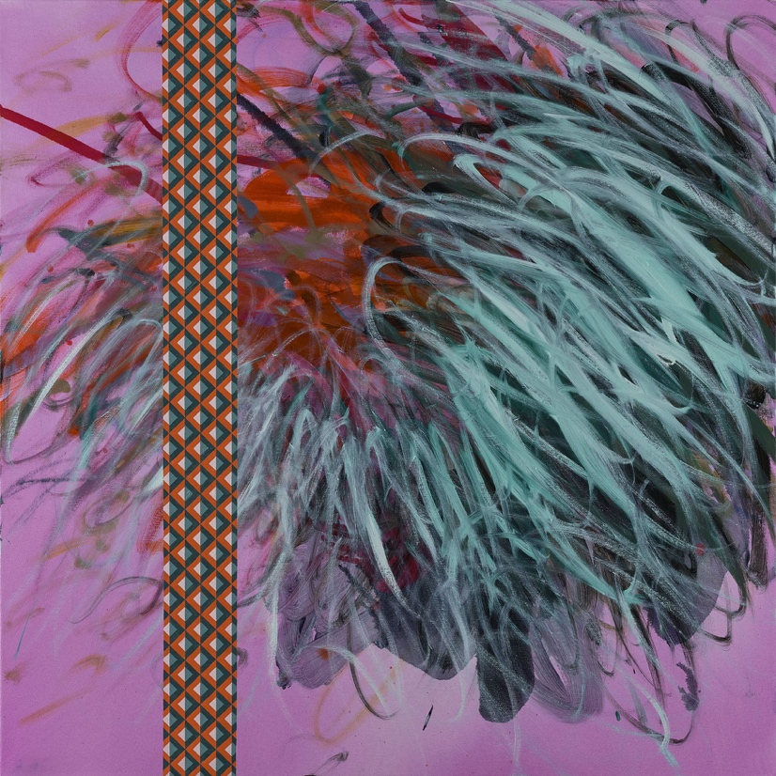

Jennifer Morrison, Prophecy, 2022, oil on canvas, 90 x 90 cm

Barnard is pleased to present South African born, UK-based painter, Jennifer Morrison’s first solo exhibition in Cape Town titled The Depth of Things. Morrison graduated from Central Saint Martin’s College of Art and Design in London where she currently lives and works. The artist’s paintings project a preoccupation with colour, texture, form and the richness and flexibility of oil paint; they are unapologetically fierce in their celebration of the process of painting wherein the medium and method of their making is itself the message.
Having explored the language of abstraction in painting for decades she is drawn to the relationship of one colour to another, mark making and the quality of brushstrokes. Morrison’s swirling, gestural marks are immediate and direct and challenge the viewers expectation of a painting: Telling a story is not her objective; it is the visual, emotional, intuitive impact and experience that is central to her practice. Morrison is interested in how to paint rather than what to paint. Elaborating on this the artist says “… just as a series of musical notes can convey a feeling, a mood, a memory, so can abstract painting. We all understand and interpret abstract qualities like rhythm, repetition, soft notes, the darkness or brightness of colours, areas of emptiness, the direction of marks. Small children can understand this; it is a language.”

For Morrison, it is important that the work deliver a rich experiential encounter. The formal qualities of abstract painting are significant not in themselves but as part of a work’s expressive message. Painting, for Morrison, is about exploring the invented object, of comprehending a work in a literal and experiential sense. She sees it as a kind of honesty. ‘‘I don’t need to know what a painting means. For some people, there seems to be a need for something else to be attached to it. I’m not really sure why this is but it might be to do with the notion that art is somehow validated if it is about something, particularly if it ticks the current boxes like identity, environment and so on. I don’t need art to tell me a story or give me a message to educate me.’’ she notes. In this new series of works Morrison juxtaposes and contrasts her gestural and intuitive mark making with more formal, intricately painted geometrical strips - a deliberate and controlled section of each painting, bringing two sides of her personality together; her physical and energetic and her more ordered, controlled, precise and cerebral side.

To date Morrison has had solo shows in Durban, Johannesburg and London and her works can be found in private collections in South Africa, Singapore, United States, Australia, and the UK.

<ENDS >

Words: 448
Issued by: Bongiwe Nocanda
Barnard Gallery
bongiwe@barnardgallery.com
0609324678

